Submitted by Rana Abdulrehman
Program Batch 3rd Artificial Intelligence (Evening)
Submitted to Sir Adeel
Institute Tech-Hub
GitHub Profile rabdul-26/Tech-Hub

Command: chmod
The chmod (change mode) is used to modify file or folder permissions in Linux.
Permissions control who can read (r), write (w), or execute (x) a file.
We used chmod +x filename to add execute permission so a script can run as a program.
Example: chmod +x myscript.sh → allows running it with ./myscript.sh.
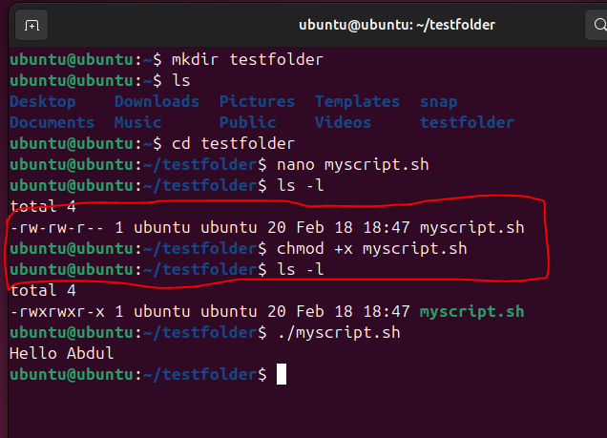
Command: ps
The ps (process status) displays information about currently running processes.
It shows details like PID (Process ID), CPU usage, memory usage, and command name.
It is useful for monitoring system activity or finding a process to stop.
Example: ps shows current terminal processes, while ps aux lists all system processes.
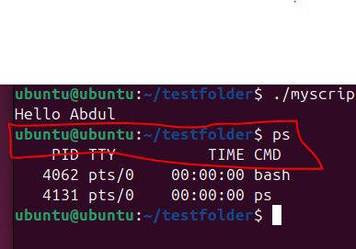
Command: Kill ID
The kill is used to terminate a running process using its PID obtained from ps.
It sends a signal (default: polite stop request) to end that process.
If the process doesn’t stop, kill -9 PID forcefully terminates it.
Example: kill 2345 stops process with ID 2345.
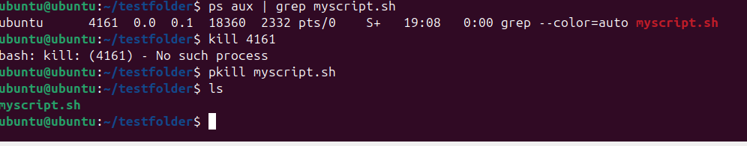
Command: Sudo apt update
The apt is Ubuntu’s package manager, and update refreshes the list of available software packages. Sudo gives administrator privileges required to access system repositories. This command does not install updates, it only checks for new versions.
Example: sudo apt update prepares the system before running upgrades.

